Experiment No. 11
Link Jira Tasks with Confluence for Library Management System

Aim
To integrate Jira work items with Confluence for the Library Management System project, enabling centralized task tracking, status monitoring, and visualization of sprint progress through embedded Jira issues and a progress indicator.

Software Requirements
Software | Version
Jira Cloud | Cloud Version
Confluence Cloud | Cloud Version
Google Chrome / Microsoft Edge | Latest Version

Theory
Confluence is a collaboration and documentation tool provided by Atlassian, while Jira is a project management and issue-tracking application. Integrating Jira with Confluence enables project teams to embed Jira work items directly into Confluence pages, providing real-time visibility of project progress.
The Jira macro displays issue details such as status, assignee, and priority, while a progress indicator helps monitor sprint completion efficiently. This integration improves communication, collaboration, and project documentation.

Procedure
Step 1: Create a Library Management System Project in Jira
- Log in to Jira Cloud.
- Click Create Space → Software Development.
- Select the Scrum template.
Enter the following details:
- Project Name: Library Management System
- Project Key: LMS
- Click Create.
Step 2: Create Jira Work Items
Open the Backlog and create the following Jira work items.
Issue ID | Summary | Status
LMS-1 | Develop Book Search Functionality | Done
LMS-2 | Create User Login Page | In Progress
LMS-3 | Implement Book Borrowing Module | To Do
LMS-4 | Design Librarian Dashboard | In Progress
LMS-5 | Test Book Return Module | Done

Arrange the work items so that their statuses appear under To Do, In Progress, and Done.
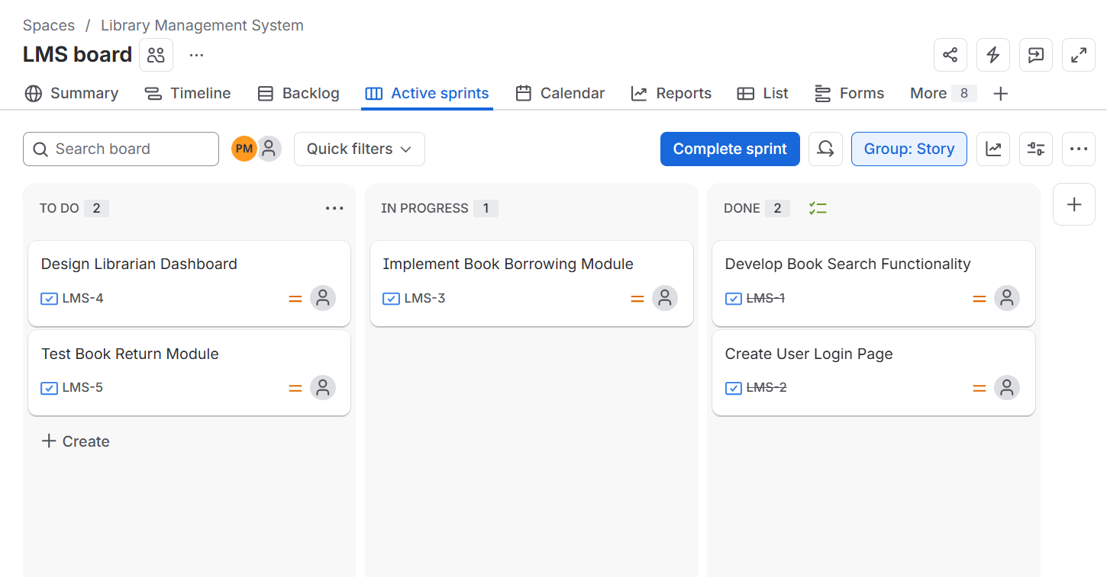

Step 3: Open Confluence
- Open your Atlassian Workspace.
- Select Confluence.
- Click Create to create a new page.
Step 4: Create a New Confluence Page
Create a page with the title: "Library Management System Project Overview"
Step 5: Add the Project Description
Below the page title, enter the following description:
"The Library Management System project is designed to automate library operations such as user login, book searching, borrowing, and returning books. This page provides an overview of the project tasks and tracks their current development status by integrating Jira work items into Confluence."
Step 6: Add a Heading
Create the heading: "Development Tasks"
Step 7: Insert Jira Work Items
- Place the cursor below the heading.
- Type /jira.
- Select Jira Work Items.
- Search for the Library Management System project.
Select the following Jira issues:
- LMS-1 – Develop Book Search Functionality
- LMS-2 – Create User Login Page
- LMS-3 – Implement Book Borrowing Module
- LMS-4 – Design Librarian Dashboard
- LMS-5 – Test Book Return Module
- Click Insert.
Verify that the embedded Jira work items display their current status (To Do, In Progress, and Done).
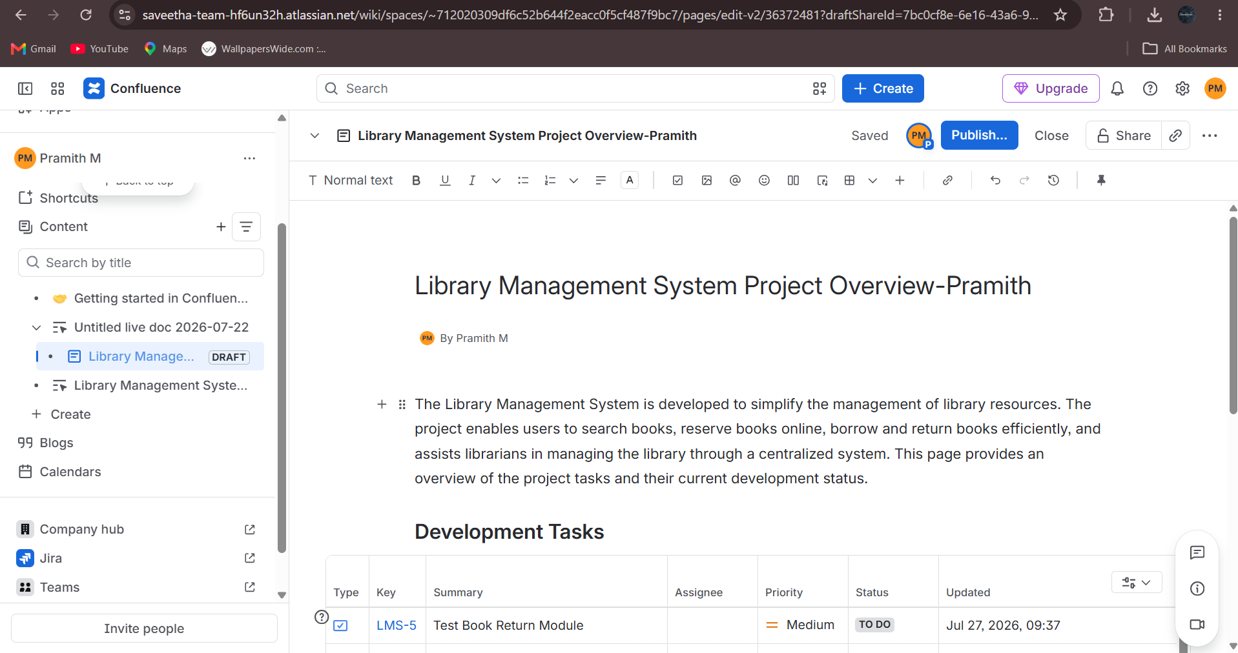

Step 8: Publish the Page
- Review the page contents.
Ensure that:
- The page title is correct.
- The project description is present.
- Five Jira work items are embedded.
- The task status is displayed correctly.
- The progress indicator is visible.
- Click Publish.
Step 9: Verify the Page
Review the published Confluence page to ensure that:
- The page title is displayed correctly.
- All five Jira work items are embedded successfully.
- Task statuses (To Do, In Progress, and Done) are visible.
- The progress indicator accurately reflects the sprint completion.
- The page is properly formatted.
- 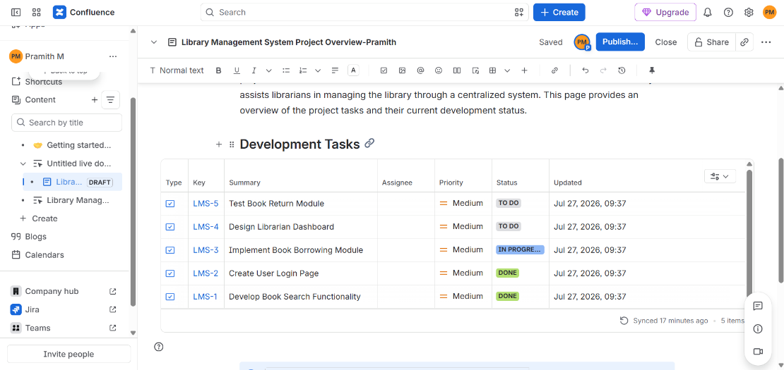

Figure 1. Library Management System Project Overview Page.

Observation
Embedded Jira Task | Status
Develop Book Search Functionality | Done
Create User Login Page | In Progress
Implement Book Borrowing Module | To Do
Design Librarian Dashboard | In Progress
Test Book Return Module | Done

Result
The Library Management System Project Overview page was successfully created in Confluence. Five Jira work items were embedded using the Jira macro, and their current status was displayed successfully. A progress indicator was added to visualize sprint completion, enabling efficient task tracking, collaboration, and progress monitoring throughout the project.

